# Project Perceiving the World through Technology Milestone 1 - Product Definition and Plan

Navigna Reddy Gangumalla

Sulaiman H S H Sultan

Nehal Anilkumar Kathiriya

Aditya Dixit

Sketch:

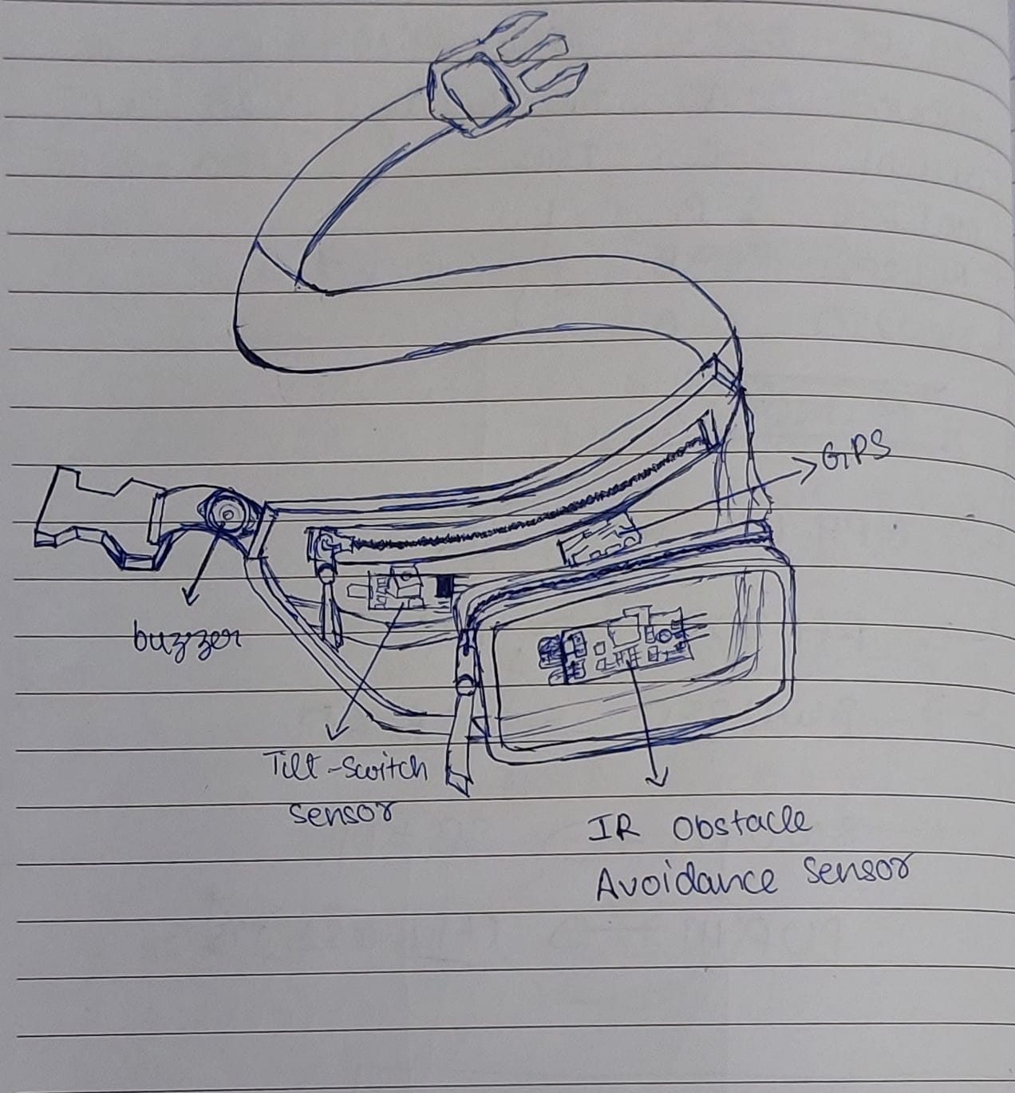

Description:

After discussing every part of the project, we decided to select the design 1.We also added the GPS sensor which was given in the design 2 to our final project.

Project description:

The project aims to develop a portable sensor system that can assist visually impaired individuals in navigating their surroundings with greater ease and safety.

The system consists of three sensors, including a GPS sensor, IR Obstacle Avoidance Sensor and a Tilt-Switch sensor along with a buzzer that provides audible feedback.

The GPS sensor provides the user with their current location, which can be used to navigate to a desired destination. The IR sensor detects obstacles in the path of the user and provides a warning through the buzzer, which helps the user to avoid collisions. The tilt sensor detects changes in the orientation of the user, which can help the user to maintain balance and avoid falls.

The system is designed to be easy to carry and use, with the sensors mounted on a fanny pack that can be worn around the waist. The user can activate the system with a simple button press, and the audio feedback from the buzzer helps to guide the user through their environment

Requirements:

GPS: The GPS sensor provides the user with their current location, which can be used to navigate to a desired destination.

IR sensor: The IR sensor is used to detect the presence of objects in the person's path. The requirement for this component is that it should be able to detect objects accurately and at a reasonable distance.

Tilt sensor:It detects changes in the orientation of the user, which can help the user to maintain balance and avoid falls.

Buzzer: The buzzer is used to provide an audio output when an object is detected. The requirement for this component is that it should be loud enough to be heard by the person wearing the fanny pack but not too loud that it disturbs others.

Power source: The fanny pack will need a power source to operate the sensors and the buzzer. The requirement for this component is that it should be long-lasting and easy to recharge or replace.

User interface: The fanny pack will need a user interface to turn on/off the device and to adjust the settings. The requirement for this component is that it should be user-friendly and easy to understand.

Overall, the project requirements include the accurate GPS system, reliable IR sensor, sensitive tilt sensor, appropriately loud buzzer, long-lasting power source, and user-friendly interface. The end product should be a fanny pack that is easy to carry and can help the person wearing it detect objects and detect falls.